

Dr. Susan, Morales inc.

2022-09-09

Dr. Morales

Unit 7795 Box 9991, DPO AE 03550

Phone: 5616801208

Fax: 8865139307

**Re:** Jaclyn, Young

**PHN:** 9769131960

**Birthdate:** 01-Nov-1964

**Address:** 76109 Steven Streets Apt. 652, Jennifermouth, RI 07621

**Patient number:** 4376813125

To Whom It May Concern:

This is a medical letter to state the above patient is pregnant with expected delivery date of 07-Aug-2025. Hoping this information is satisfactory for your requirements.

Thank you.

Sincerely,

Dr. Susan, Morales

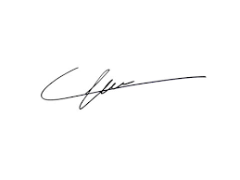

FRCS© NCMP

Clinical Assistant Professor, UBC

Department of Obstetrics and Gynecology SMH